Experiment Date: 25/2/2019-1/3/2019

Date Submitted: 8/3/2019

experiment 20: Brewing Fermentation

Bethany Mulliner – Group A4

|  |  |
| --- | --- |
| **Topic** | **Page Number** |
| **Title Page** | 1 |
| **Contents Page** | 2 |
| **Introduction** | 3 |
| **Experimental Technique** | 3 |
| **Results** | 4 |
| **Discussion of Results** | 6 |
| **Conclusions** | 7 |
| **Appendix I – Example Calculations** | 8 |
| **References** | 9 |

**Contents**

**Introduction**

This experiment seeks to enable us to become familiar with fermentation. By setting-up and monitoring the reactor, we gain an understanding of the effects and the importance of bioreactor conditions, such as sterility, temperature and pH on the bioreactor performance and hence product quality. [1]

The production of ethanol by yeast in anaerobic conditions takes place according to:

$$C_{6}H_{12}O_{6}→2CO_{2}+2CH_{3}CH_{2}OH$$

[1] Hence, by comparing the theoretical and experimental values for the amount of carbon dioxide produced, the extent of reaction under anaerobic conditions can be calculated. By comparing the specific gravity of the beer before and after fermentation, the final alcohol content can also be calculated.

**Experimental Technique**

Equipment

* 25l fermentation vessel
* Agitator unit
* Gas flowmeter
* Thermocouple
* Coopers Dark Ale 40 Pint 1.7kg Home Beer Brew Kit
* 1kg brewing sugar
* 1 capful bleach powder
* Paper towels
* Hydrometer
* 250ml beaker
* 100ml measuring cylinder
* Water source
* Kettle
* Microscope
* Microscope slides

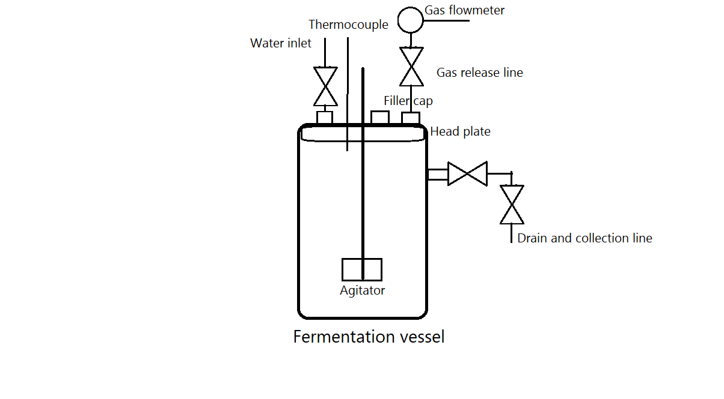Diagram

Methodology

1. The fermentation vessel head plate was removed.
2. The fermentation vessel interior was wiped down using dry paper towels to remove any residue from the inner walls.
3. The head plate was replaced, ensuring that a tight seal was formed.
4. Ensuring the drain was closed, the water inlet valve was opened, and the fermentation vessel was filled with water. A capful of bleach power was then added to the vessel through the filler cap.
5. The agitator was switched on for a few seconds to speed up the mixing of the bleach solution.
6. The cleaning solution was left to sit for a few minutes, before the vessel drain valves were opened.
7. The drain valves were closed again, and the tank was refilled with water to remove any remaining residue and bleach solution, before the drain valves were reopened.
8. Once the tank was empty, the drain valves were closed.
9. The fermentation vessel was filled with water to the 20l mark. The contents of the beer kit were then added, as well as the brewing sugar.
10. The vessel temperature was checked, and brought up to 21˚C using hot water. The agitator was then switched on until mixing was seen to be thorough through the viewing window.
11. A sample was taken from the drain valve using a beaker and measuring cylinder.
12. The specific gravity of the sample was measured using a hydrometer.
13. The reading on the gas meter was recorded and the line was ensured to be connected.
14. The yeast was then added, and hot and cold water were added as needed to make the reactor up to 23l and ensuring that the temperature remained at 21˚C.
15. The agitator was again briefly switched on to ensure proper mixing.
16. The mixture was left to ferment for 5 days and the gas meter and vessel temperature readings were taken at least daily.
17. On the final day, a sample of the beer was taken, and the specific gravity was measured again, and the final vessel temperature was recorded. The sample was inspected under a microscope to confirm that no microorganisms other than the yeast which had been used in the fermentation were present.

**Results**

A Cooper’s Dark Ale beer kit was allowed to ferment over a period of 96 hours. During this fermentation period, the production of CO2 and the temperature of the fermentation vessel was recorded. Note that times have been converted into a decimal format for ease of data processing.

|  |  |  |
| --- | --- | --- |
| Time, hours | CO2 Produced, L | Temperature, ˚C |
| 0.00 | 0.0 | 21.0 |
| 21.88 | 47.4 | 23.0 |
| 28.00 | 103.1 | 23.7 |
| 46.28 | 257.2 | 23.2 |
| 75.75 | 372.7 | 22.0 |
| 96.00 | 376.5 | 21.0 |

The graph showing the production of carbon dioxide over time displays a clear sigmoid curve, showing the rate of production initially increasing, before becoming steady and finally declining.

The graph showing the fermentation vessel temperature with respect to time shows that the temperature of the vessel during the experiment varied by only a maximum of 2.7˚C, suggesting that this factor will have had little effect on the other collected results.

As well as these results, the specific gravity of the beer was also measured at the start and at the end of the fermentation period. From this, the sugar content and the alcohol by volume could be calculated.

Initial specific gravity – 1044

Final specific gravity – 1010

Initial sugar content – 120g/L

Final sugar content – 30g/L

Alcohol by volume – 4.56%

The amount of carbon dioxide produced could also be compared with the theoretical values:

Theoretical carbon dioxide (using initial sugar present in reaction) – 643.3L

Theoretical carbon dioxide (using actual amount of sugar consumed) – 482.5L

Actual carbon dioxide – 376.5L

Using these results, the actual ABV can also be compared with the theoretical values:

Theoretical ABV (using initial sugar present in reaction) – 6.13%

Theoretical ABV (using actual amount of sugar consumed) – 4.60%

Actual ABV – 4.56%

Manufacturer suggested ABV – 5.2% [2]

**Discussion of Results**

Upon inspection of the beer on the final day of fermentation, the vessel was checked for signs of fermentation. Through the viewing window, there was a large amount of foam that had formed on top of the liquid in the vessel. The final fermentation vessel temperature was recorded, then, a sample was taken of the beer. The final specific gravity was measured to be 1010.

As can be seen on the graph depicting the production of carbon dioxide with respect to time, there is a clear sigmoid curve relationship showing the rate of production of carbon dioxide, and hence ethanol, initially increasing, before becoming steady and finally declining. This is a curve typical of the growth of yeast and can be explained as follows. [3]

Initially, there is only a little yeast in the tank and a large amount of available sugar, hence not much sugar is converted into carbon dioxide and ethanol. As time progresses, the yeast in tank being to multiply, until the sugar the tank is being consumed and converted at a much faster rate. Finally, as can be seen on the graph, towards the end of the fermentation, the rate slows down dramatically, due to both a lack of available sugar for a large proportion of the yeast to convert, and the death of some yeast cells due to the increasing level of ethanol in the tank. [4] [5]

On the second graph, the temperature in the tank is shown to increase, plateau somewhat, then decrease back to the base level. This is as expected, as the fermentation of sugar is an exothermic reaction, producing an amount of heat as the reaction progresses. [6] As the temperature begins to plateau, the reaction can be said to be slowing down, and once it begins to drop, it has slowed to such a rate where heat is being released faster from the reactor than it is being produced by the fermentation reaction. If more measurements had been taken, and if the fermentation had been run for another 24 hours, it may have been possible to identify the time at which the reaction had effectively ‘stopped’, due to all viable yeast using up the majority of the available sugar.

The sample taken was also viewed under a microscope, to identify if any harmful microorganisms were present which would make the beer unsafe for consumption. Upon inspection, the sample was shown to only contain yeast cells, suggesting that our thorough sterilisation of the tank before the fermentation began was sufficient in preventing the growth of harmful bacteria.

During the experiment, we made a slight error, and only made the tank up to 20l, instead of the beer kit manufacturer’s suggested volume of 23l. This was accounted for in all calculations made. As a result of this, a stronger beer was produced than would have been expected for a larger volume, as the solution was more concentrated. The actual amount of carbon dioxide produced varied largely from both theoretical values that had been calculated, using the values for the amount of sugar initially present, and the amount of sugar consumed in the reaction.

For the first case, where the amount of carbon dioxide varies from the value for the amount of sugar initially present, this variation can be explained by the fact that anaerobic fermentation would not have been occurring at the start of the experiment, as some air would have initially been present in the tank once the tank was sealed, affected the amount of gas flow measured significantly. For the second case, where the amount of carbon dioxide varies from the value for the amount of sugar consumed in the reaction, this variation can be explained by small leaks that may have been present in the fermentation vessel. Indubitably, some amount of gas must have escaped from the seal between the head plate and the vessel, as well as between the agitator and the vessel, which was only sealed with tape to prevent loss of gas. As a result of these losses of gas to the atmosphere, they were not counted by the gas flowmeter, hence leading to this discrepancy.

A final issue is that in reality, one cannot assume that all the sugar will react, or will even be glucose, as the malt extract will contain sugars that cannot be broken down by the yeast. Also, the distribution of the sugar and the yeast throughout the vessel means that it will not be possible for every sugar molecule to be available to the yeast due to the randomness resulting from any mixing. Hence, this is a further reason why the amount of carbon dioxide produced and the alcohol by volume values were both lower than anticipated.

**Conclusions**

The experiment sought to enable us to become familiar with fermentation. By comparing the theoretical and experimental values for the amount of carbon dioxide produced during the fermentation experiment, the extent of reaction under anaerobic conditions can be calculated. By comparing the specific gravity of the beer before and after fermentation, the final alcohol content can also be calculated.

It was found that less carbon dioxide and hence a lower final alcohol content were produced than expected, due to non-ideal fermentation conditions relating primarily to reactor sealing. Otherwise, the produced beer was found to have an alcohol by volume value of 4.56%, and was found not to contain any harmful bacteria that would have made it unsafe for consumption.

**Appendix I – Example Calculations**

$$C_{6}H_{12}O_{6}→2CO_{2}+2CH_{3}CH_{2}OH$$

Theoretical carbon dioxide (using initial sugar present in reaction)

Initial sugar content = 120g/L

Volume in vessel = 20L

Molar mass of glucose = 180gmol-1

Temperature – 21.0˚C

$$Total mass=120×20=2400g$$

$$Initial moles of glucose= \frac{Total mass}{Molar mass of glucose}=\frac{2400}{180}=13.\dot{3} moles$$

According to reaction stoichiometry:

$$Moles of CO_{2} Produced=2×Initial moles of glucose=2×13.\dot{3}=26.\dot{6} moles$$

Ideal gas law:

$$V=\frac{nRT}{P}=\frac{26.\dot{6}×8.314×294}{101325}×1000=643.3L$$

Theoretical carbon dioxide (using actual amount of sugar consumed)

$$Total mass=90×20=1800g$$

$$Initial moles of glucose= \frac{Total mass}{Molar mass of glucose}=\frac{1800}{180}=10 moles$$

According to reaction stoichiometry:

$$Moles of CO_{2} Produced=2×Initial moles of glucose=2×10=20 moles$$

Ideal gas law:

$$V=\frac{nRT}{P}=\frac{20×8.314×294}{101325}×1000=482.5L$$

Theoretical ABV (using initial sugar present in reaction)

Molar mass of ethanol = 46g/mol

Assuming a density of 1000g/L.

According to reaction stoichiometry:

$$Moles of Ethanol Produced=2×Initial moles of glucose=2×13.\dot{3}=26.\dot{6} moles$$

$$Mass of ethanol produced=26.\dot{6}×46=1226.\dot{6}g$$

$$Volume of ethanol produced= \frac{1226.\dot{6}}{20}×100=6.13\%$$

Theoretical ABV (using actual amount of sugar consumed)

According to reaction stoichiometry:

$$Moles of Ethanol Produced=2×Initial moles of glucose=2×10=20 moles$$

$$Mass of ethanol produced=20×46=920g$$

$$Volume of ethanol produced= \frac{920}{20}×100=4.60\%$$

# **References**

|  |  |
| --- | --- |
| [1] | Heriot-Watt University School of Engineering & Physical Sciences, Brewing fermentation, Edinburgh: Heriot-Watt University, 2016. |
| [2] | The Home Brew Shop, "Coopers Dark Ale Beer Kit," [Online]. Available: https://www.the-home-brew-shop.co.uk/acatalog/Coopers_40_pint_Classic_Old_Ale_Dark_Ale_Beer_Kit_.html. [Accessed 7 March 2019]. |
| [3] | P. M. Doran, in *Bioprocess Engineering Principles*, Sydney, Elsevier, 1995, pp. 38-39. |
| [4] | M. Battack and S. Azam-Ali, Fermented Fruits and Vegetables: A Global Perspective, Rome: Food and Agriculture Organisation of the United Nations, 1998. |
| [5] | I. Cristian Trelea, M. Titica, S. Landaud, E. Latrille, G. Corrieu and A. Cheruy, "Predictive modelling of brewing fermentation: from knowledge-based to black-box models," *Mathematics and Computers in Simulation,* no. 56, pp. 405-424, 2001. |
| [6] | E. O. Walsh, Introduction to Biochemistry (Second Edition), Aylesbury: The English Universities Press , 1968. |